

PHYSICAL EDUCATION STUDIES

**Year 12 General**

**Task 8: BIOMECHANICS and EXERCISE PHYSIOLOGY INVESTIGATION**

**2019**

**Question Booklet**

Name: ____________________________________

***Time allowed for this investigation***

Time will be allocated in class Three Weeks

|  |  |  |
| --- | --- | --- |
| ***Material required/recommended for this paper***  **To be provided by the Teacher**  This Question booklet  **To be provided by the candidate**  Standard items:Pens, pencil, eraser, correction fluid, highlighter, ruler,  General Physical Education Studies Text book |  |  |

**TASK OUTLINE MARKS: / 60**

Students need to produce individual assignments in their own words.

This task is to be completed during class time. It is the responsibility of the absent student to catch up on work outside of class time.

No extension will be given

* Unless student seek permission with a valid reason prior to due dates
* If students request an extension on due dates.
* If students are absent without a valid reason

Extensions will be decided on a case by case basis.

Late work: Students will be penalise 10% every school day including Wednesday until the assessment is handed in. If students submit their assessment over 5 school days late, they can only receive a maximum of 50% as their mark.

Students are encouraged to submit drafts before the submission date. There will not be any resubmissions after the due date.

**Time of assessment**

3 weeks

**All questions must be answered in relation to Biomechanics and Exercise Physiology Units taught this semester.**

**Part A**

**Select a skill from Touch Football your partner can perform and you are comfortable coaching. You are to fill out sections of this sheet then perform the analysis in class during our practical double period Use your analysis and data collected to answer the remainder of the questions.**

1. Outline the 5 steps to an effective analysis of a skill

(10 Marks)

1. Develop a checklist that can assist in your qualitative analysis of your partners touch football skill. (9 Marks)

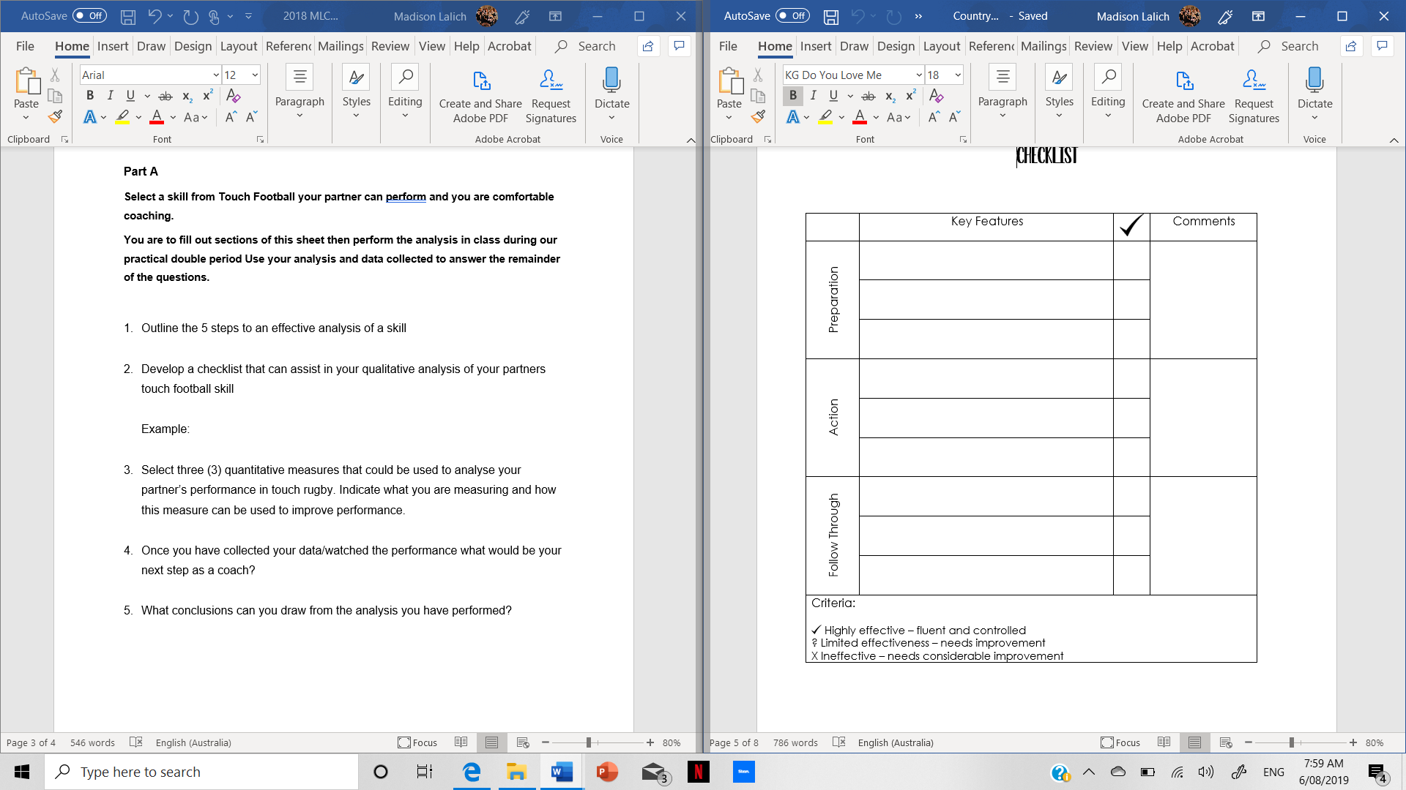

Example:

1. Select three (3) quantitative measures that could be used to analyse your partner’s performance in touch rugby. Indicate what you are measuring and how this measure can be used to improve performance.

(6 Marks)

1. Once you have collected your data/watched the performance what would be your next step as a coach?

(1 Mark)

1. What conclusions can you draw from the analysis you have performed?

(4 Marks)

**Part B**

1. You are to develop a fitness profile for a member of your class based on the sport they do the most. If your partner does not currently play a sport outside of school you must use Touch Football as their sport.

You must select a minimum of 7 fitness tests to conduct in order to have an accurate fitness profile. This testing will be done during class time.

Once you have collected all your data answer the following questions using your partner’s fitness profile. (4 Marks)

**EXAMPLE:**

**Fitness Profile of ________________________________**

|  |  |  |  |
| --- | --- | --- | --- |
| **Component of fitness** | **Test conducted** | **Result** | **Rating** |
|  |  |  |  |
|  |  |  |  |

1. Justify why you have selected the components of fitness to be tested

(4 Marks)

1. What is the purpose of developing a fitness profile for athletes?

(3 Marks)

1. Based on your partner’s profile, suggest areas of improvement and provide two (2) training methods per component of fitness that can be used to develop that component.

(9 Marks)

1. With the aid of examples discuss how two (2) principals of training can be applied to achieve improvements in a training program.

(10Marks)